
APPENDIX GA36d

LEVEL 7 ASSESSMENT SPECIFICATION

Student name: |  | Student ID number:
Programme: | MSc/PgDip/PgCert Cybersecurity and Digital Forensics
Module: | Digital Forensics Analysis
Module code: | ACCA7031 | Contribution to Overall Module Assessment (%): | 100%
Lecturer: | Dr. Nitheesh Kaliyamurthy | Internal Verifier: | Mr. Munyaradzi Murira
Assignment Title: | Research, Analyse and Investigate Cybersecurity incidents and perform digital forensic assessment | Word count (or equivalent): | 5000
Submission deadline: | 11th May 2026 AND  14th May 2026 | Return date of provisional marks & written feedback: | 20 Working Days after Submission
Submission method: | All written assessments, where practical and possible, must be submitted via Turnitin unless otherwise instructed by the Lecturer. (Please DO NOT put this assessment specification into Turnitin or it will match many similarities with other students’ submissions.)  Alternative submission method (if applicable): NA  Late submission of the assessment will result in a late penalty mark:.  Work which is submitted up to 1 week late will be capped at 50% for the first attempt and will be awarded a mark of 0% for re-assessment. Late submission penalties may be lifted only if there is an approved extenuating circumstances claim.  Work submitted more than 1 week late will be considered as a non-submission and will not be marked. The work may be considered as a submission for reassessment if offered by an Examining Board or if there is an approved extenuating circumstances claim.
Academic honesty / referencing: | Academic honesty is required. In the main body of your submission you must give credit to authors on whose research and ideas your work is based. Append to your submission a reference list that indicates the books, articles, etc. that you have used, cited or quoted in order to complete this assessment.

Module Learning Outcomes
(from module syllabus)
- provide a systematic understanding of a wide range of current research and technological advances in digital and cyber security incidents and defensive techniques;
- perform computer forensics, to assess, investigate and analyse digital and cyber security crimes of an organisation with effective usage of security tools and methodologies.

TASK DESCRIPTION

Use of Generative AI in Assessment
(Lecturer to indicate Yes or Not against each element)

RESEARCH | For this assessment, you can use Generative AI to support you in research and data analysis. | Yes ☒  No ☐
STRUCTURE | For this assessment, you can use Generative AI to support you in structuring your submission, including creating a draft argument structure, identifying parts and headings, etc. | Yes ☒  No ☐
PROOFREADING | For this assessment, you can use Generative AI to check your own text/creation for grammatical and syntactical mistakes, including getting suggestions to rephrase your work. | Yes ☒  No ☐
WRITING | For this assessment, you can use Generative AI to create text for submission. | Yes ☐  No ☒
CREATIVE | For this assessment, you can use Generative AI to create creative materials, such as images. | Yes ☒  No ☐
PROGRAMING | For this assessment, you can use Generative AI to create and check code. | Yes ☒  No ☐
NONE | For this assessment, you are not allowed to use any type of Generative AI support. This includes research support, structure support, writing/proofreading support and creative support. | ☐

Important Notes:

Each tasks have varying word lengths specified for them; it is important that you keep to the word length specified for each assessment at all times on the following grounds:
• To encourage succinct and clear writing.
• To ensure equity between all the students doing that particular assessment.

If the specified word limit for an assessment has been exceeded, the following penalties would normally apply. The penalty cannot take the work into the fail category.

• Up to 10% above the word limit – No deduction off final mark
• Between 10% and 25% above the word limit – Deduction of 5 marks off final mark, or reduce the mark to the capped mark, whichever is the lesser penalty.

For example,

For a postgraduate student achieving a final mark of 54%, the mark would be reduced to the capped mark of 50%; whereas for a postgraduate student achieving a final mark of 67%, the mark would be reduced to 62%.

• Between 25% and 50% above the word limit – Deduction of 10 marks off final mark, or reduce the mark to the capped mark, whichever is the lesser penalty.

For a taught postgraduate student achieving a final mark of 59%, the mark would be reduced to the capped mark of 50%; whereas for a postgraduate student achieving a final mark of 64%, the mark would be reduced to 54%.

• 50% or more over length – Maximum mark of capped mark

A failure to meet the word limit (or minimum word limit if a range is given) may result in lower marks based on the quality of the work because the work may not include the necessary information required for the assessment to meet the stated learning outcomes.

The feedback on the assessment should explicitly mention any mark deduction and the reason for it.

This coursework has multiple tasks, deadlines and deliverables: Summary of Deadlines and Deliverables are:

Task | Deliverables | Deadline | Marks
Task 1 | Research Report (1000 Words) | 11th May 2026 | 20
Task 2 | Digital Forensics Report  Demonstrate your Analysis | 11th May 2026  14th May 2026 | 80

Briefing

Assume you are offered an apprenticeship position as Assistant Investigator in a Digital Forensics company that deals with investigation related to Computer Forensics, Mobile Phone Forensics, Digital Media Investigations and more.

You are expected to conduct comprehensive research on topics related to digital forensics scope and industry happenings in the recent past.

You will also be involving in simulated investigations to gain hands-on experience in analysing the recovered digital evidences.

Task 1

Word Limit: 1000 words
(Individual Work)

Deliverables
Final Submission
- Research Report – 20 Marks Maximum
Date of Submission – 11th May 2026 – 1500 Hrs – Via Moodle Link
Note: This is an Individual Work

Do a research on digital forensics addressing the following
- Current state of the field, the tools – features and capabilities.
- Intersection of digital forensics and cybersecurity
- Emerging trends in Digital Forensics
- Key Challenges
- National and International Job Market

Recommendation: Refer and in-text cite academic credible literatures, text books recently published, Industry reports/ whitepapers, Job portals, news articles and et al.

Task 2

Word Limit: 4000 words equivalent

Deliverables:

- Forensic Images: Submit the acquired images (or documentation of the acquisition process) for each device.
- Digital Forensic Report (limited to 2,000 words)
- Demonstrate your method of analysis and present your findings

Date of Submission
Digital Forensics Report: 11th May 2026 at 1500 Hrs via Moodle Link
Forensics Images: 14th May 2026 (One Drive Link Shared by your Lecturer)
Demonstration: 14th May 2026 (The Schedule will be shared by your Lecturer)
Note: This is an Individual Work

You are assigned to an investigation case. Here is the briefing about the case:

“Quantum Tech’s IT security team detected unauthorized access to their proprietary patent database, specifically the AI chip design patent (ID: QT-AI-2025). Initial findings point to Emma, a senior engineer, joined recently at Quantum Tech’s as the primary suspect. The company suspects Emma attempted to steal and sell these patents to a competitor, NexGen Circuits, through an intermediary, Joe.

You are provided with the following digital evidence, seized under proper continuity-of-evidence protocols:
- Emma’s Android Smartphone
  - Contains communication logs (WhatsApp, Instagram DMs, emails) and call records.
- Emma’s USB Flash Drive
  - Contains files related to the patent.
- Joe’s Smartphone
  - Contains communication logs (WhatsApp, Instagram DMs) and call records.
- Norman’s Android Smartphone
  - Contains communication logs (WhatsApp, emails) and call records. Vanessa is the R&D Director at NexGen Circuits and a suspected buyer.

Quantum Tech has reported the incident to law enforcement, and your findings will be used to support legal action against the perpetrators for corporate espionage, theft, and potentially any other crime if reported.

Complete the following tasks to conduct a thorough and professional investigation:
- Evidence Acquisition:
  - Acquire forensic images of Emma’s, Norman’s and Joe’s smartphone and Emma’s USB flash drive using industry-standard tools (e.g., Cellebrite, FTK Imager, or Autopsy).
  - Document the continuity of evidence for each device, ensuring integrity and admissibility of evidence.
  - Verify the hashes (e.g., MD5, SHA-1) of the acquired images to confirm no tampering.

- Communication Analysis:
  - Extract and analyse communication logs from WhatsApp, Instagram DMs, and emails across all three smartphones.
  - Reconstruct a timeline of interactions between Emma, Joe, and Norman.
  - Identify key discussions related to the theft and sale of the QT-AI-2025 patent, including any mentions of payment, meeting arrangements, or file transfers.

- File Analysis:
  - Examine the contents of Emma’s USB flash drive to identify files related to the QT-AI-2025 patent (e.g., PDFs, CAD designs).
  - Investigate any additional files that may constitute other evidences.
  - Analyse file metadata (e.g., creation dates, modification dates) to determine when and how the files were created or copied.

- Call Log and Email Correlation:
  - Cross-reference call logs from all three smartphones to confirm communication events, such as a key call between Emma, Joe and Vanessa.
  - Analyse email exchanges, particularly those involving patent sample transfers, to verify the intent to sell proprietary data.

- Suspect Profiling:
  - Based on the evidence, determine the roles and motives of Emma (perpetrator), Joe (intermediary), and Norman (buyer).
  - Identify any additional evidence that supports or refutes their involvement in the corporate fraud.

- Forensic Images:
  - Submit the acquired images (or documentation of the acquisition process) of Emma (perpetrator), Joe (intermediary), and Norman (buyer).

- Forensic Report:
  - Write a professional forensic investigation report that includes:
    - Case Background: Summary of the incident and investigation scope.
    - Evidence Inventory: List of devices and their chain-of-custody details.
    - Methodology: Tools and techniques used for acquisition and analysis.
    - Findings: Detailed timeline, communication analysis, file analysis, and suspect roles.
    - Conclusion: Summary of the evidence proving the attempted theft and any illegal materials.
    - Recommendations: Actions for Quantum Tech and law enforcement (e.g., charges for corporate espionage, possession of illegal content).
  - Ensure the report is clear, concise, and admissible in a legal context.

- Demonstrate your analysis and outcomes:
  - During the scheduled time, demonstrate the Investigation Process and analysis methods to determine the roles and motives of Emma (perpetrator), Joe (intermediary), and Norman (buyer) with adequate evidences and the outcomes of your investigation fluently with clarity

Guidelines
- Professionalism: Adhere to forensic best practices, including maintaining evidence integrity, using write-blockers, and documenting all steps.
- Tools: Use forensic software such as Autopsy, FTK, Cellebrite, or open-source tools like Sleuth Kit.
- Ethics: Handle evidence of illegal materials appropriately, noting their presence without distributing or accessing them unnecessarily.

Notes
- Assume all devices are unlocked or passwords are provided by Quantum Tech.
- Focus on the digital evidence provided; do not speculate beyond the data.
- If you encounter challenges (e.g., encrypted files, deleted messages), note them in the report and suggest recovery methods.

Good luck, investigators! Your expertise is critical to uncovering the truth and protecting Quantum Tech’s intellectual property.

Marking Scheme:

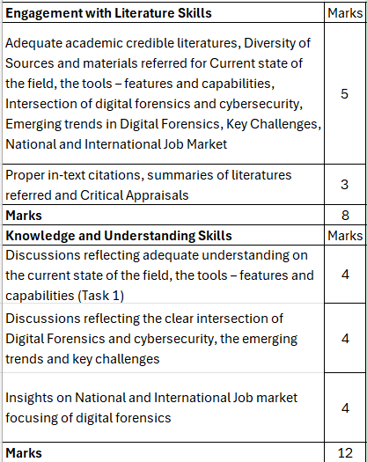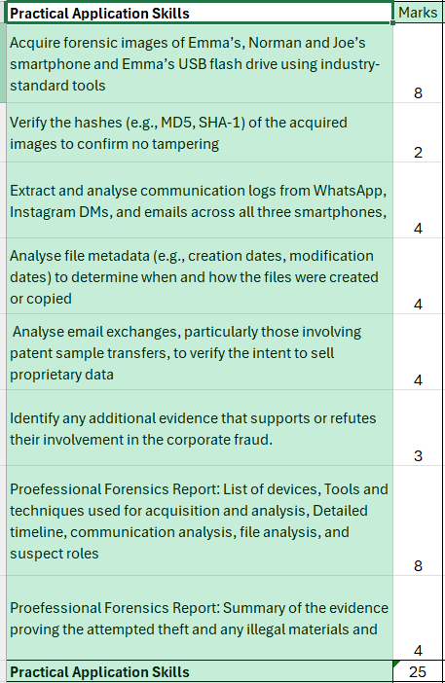

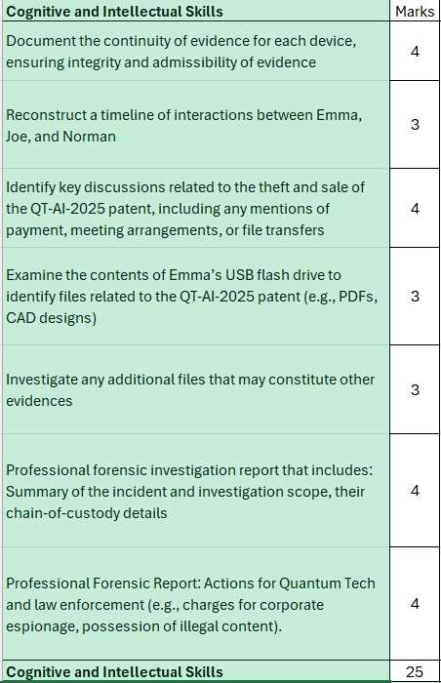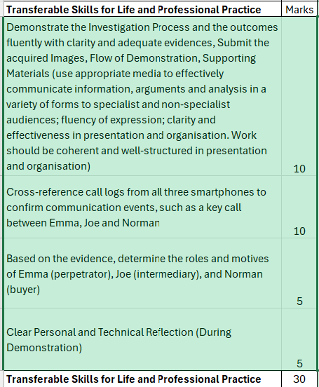

GUIDANCE FOR Students IN THE COMPLETION OF TASKS

NOTE: The guidance offered below is linked to the five generic assessment criteria overleaf.

- Engagement with Literature Skills
Your work must be informed and supported by scholarly material that is relevant to and focused on the task(s) set; you should make use of scholarly reviews and primary sources, as appropriate (for example, refereed research articles and/or original materials appropriate to the discipline). You should provide evidence that you have accessed a wide range of sources, which may be academic, governmental and industrial; these sources may include academic journal articles, textbooks, current news articles, organisational documents, and websites. You should consider the credibility of your sources; academic journals are normally highly credible sources while websites require careful consideration/selection and should be used sparingly. Any sources you use should be current and up-to-date, mostly published within the last five years or so, though seminal/important works in the field may be older. You must provide evidence of your research/own reading throughout your work, using correctly a suitable referencing system, including in-text citations in the main body of your work and a reference list at the end of your work.

Guidance specific to this assessment: Adequate academic credible literatures, proper in-text citations, summaries of literatures referred and Critical Appraisals on Current state of the field, the tools – features and capabilities, Intersection of digital forensics and cybersecurity, Emerging trends in Digital Forensics, Key Challenges, National and International Job Market.

- Knowledge and Understanding Skills
At level 7, you should be able to demonstrate a systematic understanding of knowledge, and a critical awareness of current problems and/or new insights, much of which is at, or informed by, the forefront of your academic discipline, field of study or area of professional practice, with a comprehensive understanding of techniques applicable to your own research or advanced scholarship. Your work must demonstrate your growing mastery of these concepts, principles, current challenges, innovation and insights associated with the subject area. Knowledge relates to the facts, information and skills you have acquired through your learning. You demonstrate your understanding by interpreting the meaning of the facts and information (knowledge). This means that you need to select and include in your work the contemporary concepts, techniques, models, theories, etc. appropriate to the task(s) set. You should be able to explain the theories, concepts, etc. meaningfully to show your understanding. Your mark/grade will also depend upon the extent to which you demonstrate your knowledge and understanding; ideally each should be complete and detailed, with comprehensive coverage.

Guidance specific to this assessment: Discussions reflecting adequate understanding on the current state of the field, the tools – features and capabilities, clear intersection of Digital Forensics and cybersecurity, the emerging trends and key challenges, insights on National and International Job market focusing of digital forensics

- Cognitive and Intellectual Skills
You should be able to: evaluate critically current research and advanced scholarship in the discipline; evaluate methodologies and develop critiques of them and, where appropriate, to propose new hypotheses; deal with complex issues both systematically and creatively to make sound judgements in the absence of complete data. Your work must contain evidence of logical, analytical thinking, evaluation and synthesis. For example, to examine and break information down into parts, make inferences, compile, compare and contrast information. This means not just describing what! But also justifying: Why? How? When? Who? Where? At what cost? At all times, you must provide justification for your arguments and judgements. Evidence that you have reflected upon the ideas of experts within the subject area is crucial to you providing a reasoned and informed debate within your work. Your choice of methodologies to gather data and information must be rigorously defended. Furthermore, you should provide evidence that you are able to make sound judgements and convincing arguments using data and concepts. Sound, valid, persuasive conclusions are necessary and must be derived from the content of your work. Where relevant, alternative solutions and recommendations may be proposed.

Guidance specific to this assessment: Document the continuity of evidence for each device, ensuring integrity and admissibility of evidence, Reconstruct a timeline of interactions between Emma, Joe, and Norman, Identify key discussions related to the theft and sale of the QT-AI-2025 patent, including any mentions of payment, meeting arrangements, or file transfers, Examine the contents of Emma’s USB flash drive to identify files related to the QT-AI-2025 patent (e.g., PDFs, CAD designs), Investigate any additional files that may constitute other evidences, write a professional forensic investigation report that includes: Summary of the incident and investigation scope, chain-of-custody details, Actions for Quantum Tech and law enforcement (e.g., charges for corporate espionage, possession of illegal content).

- Practical Skills
At level 7, you should be able to demonstrate originality in the application of knowledge, together with a practical understanding of how established techniques of research and enquiry are used to create and interpret knowledge in the discipline. This includes acting autonomously in planning and implementing tasks at a professional or equivalent level, originality in tackling and solving problems, and decision-making in complex and unpredictable contexts or situations.

You should be able to demonstrate mastery of the leading edge subject-related concepts and ideas as they relate to real world situations and/or particular contexts. How do they work in practice? You will deploy models, methods, techniques, and/or theories, in those contexts or circumstances, to assess current situations, perhaps to formulate plans or plausible, justifiable recommendations to solve problems, or to propose new models, or to create artefacts, which may be innovative and creative, thereby demonstrating your understanding of how the boundaries of knowledge are advanced through research and/or application. This is likely to involve, for instance, the use of real world artefacts, examples and cases, the application of a model within an organisation and/or benchmarking one theory or organisation against others.

Guidance specific to this assessment: Acquire forensic images of Emma’s, Vanessa’s and Joe’s smartphone and Emma’s USB flash drive using industry-standard tools (e.g., Cellebrite, FTK Imager, or Autopsy), Verify the hashes (e.g., MD5, SHA-1) of the acquired images to confirm no tampering, Extract and analyse communication logs from WhatsApp, Instagram DMs, and emails across all three smartphones, Analyse file metadata (e.g., creation dates, modification dates) to determine when and how the files were created or copied, Analyse email exchanges, particularly those involving patent sample transfers, to verify the intent to sell proprietary data, Identify any additional evidence that supports or refutes their involvement in the corporate fraud, professional forensic investigation report that includes: List of devices Tools and techniques used for acquisition and analysis, Detailed timeline, communication analysis, file analysis, and suspect roles, Summary of the evidence proving the attempted theft and any illegal materials.

- Transferable Skills for Life and Professional Practice
Your work must provide evidence of the qualities and transferable skills necessary for postgraduate-level employment in circumstances requiring sound judgement, personal responsibility and initiative in complex and unpredictable professional environments. This includes demonstrating: the independent learning ability for continuing professional development to advance existing skills and acquire new competences of a professional nature that will enable you to assume significant responsibility within organisations; that you can initiate and complete tasks, projects and procedures, whether individually and/or collaboratively, to a professional level; that you can use appropriate media to effectively communicate information, arguments and analysis in a variety of forms for a variety of audiences; fluency of expression; clarity and effectiveness in presentation and organisation. Work should be coherent and well-structured in presentation and organisation.

Guidance specific to this assessment: Cross-reference call logs from all three smartphones to confirm communication events, such as a key call between Emma, Joe and Vanessa, Based on the evidence, determine the roles and motives of Emma (perpetrator), Joe (intermediary), and Norman (buyer), Demonstrate the Investigation Process and the outcomes fluently with clarity and adequate evidences, Reflect clearly on your personal and technical transferable skills.

Student FEEDBACK FORM

This section details the extent to which the assessment criteria are demonstrated by you, which in turn determines your mark. The marks available for each category of skill are shown. Lecturers will use the space provided to comment on the achievement of the task(s), including those areas in which you have performed well and areas that would benefit from development/improvement.

Generic Assessment Criteria | Marks available | Marks  awarded
1. Engagement with Literature Skills  . | 8
2. Knowledge and Understanding Skills | 12
3. Cognitive and Intellectual Skills | 25
4. Practical Application Skills | 25
5. Transferable Skills for Life and Professional Practice | 30

Assessment Mark (Assessment marks are subject to ratification at the Exam Board. These comments and marks are to give feedback on module work and are for guidance only until they are confirmed. ) | Late Submission Penalties (tick if appropriate) |  | %
 | Up to 1 week late (50% Max) |  | %
 | Over 1 week late (0%) |  | %

GENERIC ASSESSMENT CRITERIA

Level 7
In accordance with the Framework for Higher Education Qualifications, at the end of Level 7 students should be able to demonstrate: a systematic understanding of knowledge, and a critical awareness of current problems and/or new insights, much of which is at, or informed by, the forefront of their academic discipline or area of professional practice; a comprehensive understanding of techniques applicable to their own research or advanced scholarship; originality in the application of knowledge, together with a practical understanding of how established techniques of research and enquiry are used to create and interpret knowledge in the discipline; conceptual understanding that enables the student to evaluate critically current research and advanced scholarship in the discipline to evaluate methodologies and develop critiques of them and, where appropriate, to propose new hypotheses. They will be able to deal with complex issues both systematically and creatively, make sound judgements in the absence of complete data, and communicate their conclusions clearly to specialist and non-specialist audiences. They will demonstrate self-direction and originality in tackling and solving problems, and act autonomously in planning and implementing tasks at a professional or equivalent level to continue to advance their knowledge and understanding, and to develop new skills to a high level. They the qualities and transferable skills necessary for employment requiring the exercise of initiative and personal responsibility; decision-making in complex and unpredictable situations/professional environments; and the independent learning ability required for continuing professional development.

Level 7 | FAIL | FAIL | MARGINAL FAIL | SATISFACTORY  (Pass) | GOOD to VERY GOOD  (Merit) | EXCELLENT  (Distinction) | EXCEPTIONAL  (Distinction)
Category | 0-29% | 30-44% | 45-49% | 50-59% | 60-69% | 70-84% | 85-100%
Engagement with literature (including current research, referencing,  academic conventions and  academic honesty) | Little or no evidence of reading and/or reliance on inappropriate sources.  Views and findings mostly unsupported and non-authoritative.  Referencing conventions used incoherently or largely absent. | Poor engagement with essential reading. No evidence of wider reading. Reliance on inappropriate sources, and/or indiscriminate use of sources. Heavily reliant on information gained through class contact. Inconsistent and weak use of referencing. | Engagement with a very limited range of relevant and credible sources. Some omissions and minor errors.  Referencing conventions evident though not always applied accurately or consistently. | Engagement with an appropriate range of research-informed literature, including sources retrieved independently. Some over-reliance on texts. Referencing may show minor inaccuracies or inconsistencies. | Engagement with a wide range of research-informed literature, including sources retrieved independently.  Selection of relevant and credible sources. Very good use of referencing, with no/very few inaccuracies or inconsistencies. | Engagement with an extensive range of relevant and credible literature, informed by the latest research. Consistently accurate application of referencing. | Exceptional engagement with an extensive range of relevant and credible literature, informed by the latest research. High-level referencing skills consistently and professionally applied.
Knowledge and understanding (A systematic, conceptual understanding of knowledge, and a critical awareness of current problems and/or new insights, much of which is at, or informed by, the forefront of the discipline; a comprehensive understanding of techniques applicable to their own research) | Major gaps in knowledge and understanding of the subject matter is not systematic. Substantial inaccuracies. No awareness of current problems, insights or the latest research and/or advanced scholarship within the discipline. | Gaps in knowledge, with only superficial systematic understanding. Some significant inaccuracies and/or irrelevant material. No critical awareness of current problems, insights, or latest research within the discipline. | Limited knowledge and systematic understanding of the concepts and principles within the subject area, which to some marginal extent, is informed by current research and scholarship. Some critical awareness of current problems and/or new insights, but often under-developed. | Knowledge is accurate and reasonably detailed. A systematic understanding of the field of study informed by, to some extent, current research and scholarship, A critical awareness of current problems and/or new insights though this may be under-developed occasionally. | Knowledge has a well-defined focus, which is reasonably extensive, coherent and detailed, with a critical awareness of current problems and/or new insights. Exhibits good understanding of the breadth and depth of contemporary and established views, and the work is, at least in part, well-informed by current research and scholarship. | Excellent mastery of a complex and specialised area of knowledge. A systematic, excellent understanding of the concepts of the subject informed by current research and scholarship. Highly critical awareness of current problems and/or new insights. A critical, awareness of how the boundaries of knowledge are advanced through research. | Exceptional mastery of a complex and specialised area of knowledge. An exceptionally critical awareness of current problems and/or new insights. An outstanding understanding of the concepts of the subject, well-informed by current research and scholarship. A critical, sophisticated and nuanced awareness of how the boundaries of knowledge are advanced through research.
Cognitive and intellectual skills  (Critical evaluation of current research and methodologies and develop critiques of them and, where appropriate, to propose new hypotheses; make sound judgements in the absence of complete data.) | Wholly or almost wholly descriptive work. Little or no evaluation or critique or attempt at a systematic approach.  Failure to develop arguments, leading to illogical or invalid judgements. Unsubstantiated generalisations, made without use of credible evidence. | Largely descriptive work, with superficial use of critical evaluation of research and methodologies. Absent or weak development of hypotheses and judgements. Information accepted uncritically, uses generalised statements made with scant evidence and unsubstantiated opinions. Ideas sometimes illogical and contradictory. | Limited attempt at critical evaluation/ critique of current research and methodologies, tending towards description.  Limited attempt to propose new hypotheses. Can deal with complex issues but not systematically or creatively. Some evidence to support emerging judgements but these may be underdeveloped or with a little inconsistency / mis-interpretation.  May assert rather than argue a case. | Some critical evaluation/ critique of current research and methodologies, though slightly underdeveloped in places, Proposes adequate but limited new hypotheses, where relevant. Can deal with complex issues but not fully systematically or creatively. Ability to make judgements based on data (that may be incomplete) but with some tendency to assert/state opinion rather than argue on the basis of reason and evidence. | Sound critical evaluation/ critique of current research and methodologies, Proposes new hypotheses, where appropriate. Can deal with complex issues systematically and with some creativity. Ability to make sound judgements based on data (that may be incomplete) | Excellent critical evaluation/ critique of current research and methodologies, Proposes innovative hypotheses, where appropriate. Can synthesise complex issues systematically and creatively. Ability to investigate contradictory or incomplete information and make strong, persuasive, arguments and sophisticated judgements. | Exceptional critical evaluation/ critique of current research and methodologies, Proposes innovative hypotheses, where appropriate. Exemplary systematic and creative synthesis of complex issues.  Ability to investigate contradictory or incomplete information and make strong, persuasive, arguments and sophisticated, nuanced, judgements. Potential for journal publication or doctoral research.
Practical skills  (Originality / creativity in the application of knowledge, tools and techniques and in tackling and solving problems in complex and unpredictable professional situations; practical use of established techniques of research and enquiry to create and interpret knowledge in the discipline.) | Limited or no use of methods, materials, tools and/or techniques.  Little or no appreciation of the context of the application.  Limited understanding of the application of theory to practice or making appropriate links between the two.  Very weak problem-solving skills in complex and unpredictable contexts. | Rudimentary application of methods, materials, tools and/or techniques but without consideration and competence. Flawed appreciation of the context of the application.  Weak understanding of the application of theory to practice, with only occasional evidence of making appropriate links between the two. Weak problem-solving skills in complex and unpredictable contexts. | An awareness and mostly appropriate application of well-established methods, materials, tools and/or techniques, with occasional errors.  Basic appreciation of the context of the application. Theoretical knowledge and understanding applied in practice, but not always making logical links between the two.  Can identify problems and propose basic solutions without fully appreciating the complexity of unpredictable contexts. | An appropriate application of standard methods, materials, tools and/or techniques.  Clear appreciation of the context of the application. Mainly consistent, accurate and logical application of theory to practice, making appropriate links between the two.  Can identify problems and propose mostly appropriate solutions in complex and unpredictable contexts, with elements of originality. | A very good application of a range of methods, materials, tools and/or techniques.  Very good consideration of the context of the application, with perceptive insights. Can identify problems and propose appropriate solutions in complex and unpredictable contexts.  Evidence of originality and creativity. | An advanced application of knowledge, methods, materials, tools and/or techniques.  The context of the application is well considered, and insightful.  Can identify complex problems and propose excellent solutions. An excellent grasp of techniques applicable to own research or advanced scholarship.  Shows originality in application of knowledge and techniques, and of how established techniques of enquiry create and interpret knowledge in the discipline. | Exceptional application skills in complex, unpredictable, contexts, drawing skilfully on the latest research within the discipline. Can identify complex problems and propose sophisticated, original solutions.  An outstanding application of techniques applicable to own research or advanced scholarship.  Shows originality in application of knowledge and techniques, and of how established techniques of enquiry create and interpret knowledge in the discipline with assimilation and development of cutting edge processes and techniques.
Transferable skills for life and professional practice  (Exercise of self-direction, autonomy and personal responsibility; plan and implement tasks at a professional level; independent learning; use appropriate media to communicate effectively and professionally to a variety of audiences; fluency of expression; systematic approach; clarity and effectiveness in presentation and organisation.) | Communication medium is inappropriate or misapplied.  Work is poorly structured, disorganised and/or confusingly expressed. Very weak use of language and/or very inappropriate style. Little or no evidence of autonomy (or collaboration, where relevant) in the completion of tasks. Little or no evidence of the skills required in professional, postgraduate employment. | Communication medium is poorly designed and/or not suitable for the audience.  Work is poorly presented in a disjointed manner. It is loosely, and at times incoherently, structured, with information and ideas often poorly expressed. Weak use of language and/or inappropriate style. Weak independent initiative (or collaboration, if relevant). Limited evidence of the skills required in professional, postgraduate employment. | Can communicate in a suitable medium but with some room for improvement.  Mostly ordered presentation and structure in which relevant ideas / concepts are reasonably expressed. Work may lack coherence in places. Can work as part of a team, but with limited involvement in group activities.  Demonstrates some but not all of the basic skills required in professional, postgraduate employment, with some areas of minor weakness. | Can communicate effectively in a suitable format, but may have minor errors.  Mostly coherent, organised work, in a suitable structure and is for the most part clearly expressed. Can work effectively independently and/or as part of a team, with clear contribution to group activities.  Demonstrates the skills required in professional, postgraduate employment, with some areas of strength and some of minor weakness. | Can communicate well, confidently and consistently in a suitable format.  Work is coherent, fluent, well-structured and organised. Can work very well autonomously and/or as part of a team, with a good contribution to group activities.  Demonstrates comprehensive professional, postgraduate employment skills. | Can communicate professionally confidently and consistently in a suitable format.  Work is coherent, very fluent and is presented professionally. Can work autonomously with initiative. Where relevant can work professionally within a team, showing leadership skills as appropriate, managing conflict and meeting obligations. Demonstrates excellent professional, postgraduate employment skills and a strong appetite for further development. | Can communicate with an exceptionally high level of professionalism.  Work is remarkably coherent, very fluent and is presented professionally. Can work outstandingly well and professionally within a team, showing advanced leadership skills. Demonstrates exemplary professional, postgraduate employment skills and a strong appetite for further development.

THIS DOCUMENT IS ALSO AVAILABLE IN WELSH

